DATA SCIENCE MINOR PROJECT REPORT
DATA SCIENCE
PROJECT REPORT
(Project Semester January-April 2025)

INDIAN PORTS AND PERFORMANCE DASHBOARD
Submitted by
Sala Meher Raju
Registration No: 12318575
Programme and Section: B.Tech CSE, Section KM005
Course Code: INT 217
Under the Guidance of
[Dr. Baljinder Kaur, U.Id: 27952, Designation: Assistant Professor]
Discipline of CSE/IT
Lovely School of Computer Science and Engineering
Lovely Professional University, Phagwara

DECLARATION
I, Sala Meher Raju, student of B.Tech in Computer Science and Engineering under CSE/IT Discipline at Lovely Professional University, Punjab, hereby declare that all the information furnished in this project report is based on my own intensive work and is genuine.
Date:11 April, 2025 Signature: Meher
Registration No: 12318575 Name of the Student: Sala Meher Raju
CERTIFICATE
This is to certify that Sala Meher Raju bearing Registration No. 12318575 has completed INT 217 project titled, “INDIAN PORTS AND PERFORMANCE DASHBOARD” under my guidance and supervision. To the best of my knowledge, the present work is the result of his original development, effort, and study.
Signature and Name of the Supervisor: Dr. Baljinder Kaur
Designation of the Supervisor: Assistant Professor
School of Computer Science and Engineering
Lovely Professional University
Phagwara, Punjab
Date: April 11, 2025

Acknowledgement
I would like to express my sincere gratitude to my project guide, [Dr. Baljinder Kaur], Assistant Professor, Lovely Professional University, for their invaluable guidance, support, and encouragement throughout the development of this project. Their expertise in data science and visualization techniques greatly enhanced the quality of this work.
I am also thankful to the faculty members of the Discipline of CSE/IT and the Lovely School of Computer Science and Engineering for providing the necessary resources and infrastructure. Special thanks to my peers for their constructive feedback and collaboration.
Sala Meher Raju
Registration No: 12318575

Table of Contents
- Introduction
- Source of Dataset
- Dataset Preprocessing
- Analysis on Dataset (for Each Objective)
- Conclusion
- Future Scope
- References

1. Introduction
India’s maritime industry serves as a pivotal element in the nation’s economic infrastructure, facilitating the movement of goods and boosting international trade. The present project aims to deliver a comprehensive analysis of Indian ports and fleet performance using a visually intuitive and interactive Excel dashboard. Leveraging data-driven methods, this initiative explores key operational metrics including cargo traffic trends, fleet composition by age and size, productivity across major and non-major ports, and regional disparities between the eastern and western coasts. By employing pivot tables, dynamic charts, and Excel-based formulas, the project transforms raw datasets into meaningful insights. The dashboard includes trend analysis from 2010 to 2024, highlighting growth patterns and operational bottlenecks. It also provides comparative assessments, such as coastal versus overseas Gross Registered Tonnage (GRT), and evaluates ship turnaround times to identify areas for potential improvement. The objective of this study is to empower stakeholders such as port authorities, logistics managers, and policymakers with actionable intelligence to optimize port operations and contribute toward India’s maritime vision. Ultimately, the dashboard serves not just as an analytical tool but also as a decision-support system that aligns with national initiatives like the Sagarmala Programme.

The motivation for this project arises from the need to simplify complex educational data for better decision-making. As a B.Tech CSE student, I sought to apply data preprocessing, analysis, and visualization techniques learned in INT 217 to create a functional dashboard. The project involved cleaning the dataset, selecting relevant metrics, designing six charts and a table to address specific objectives, and arranging them with interactive slicers. This report provides a detailed account of the process, methodologies, and outcomes, serving as a record of my original work.
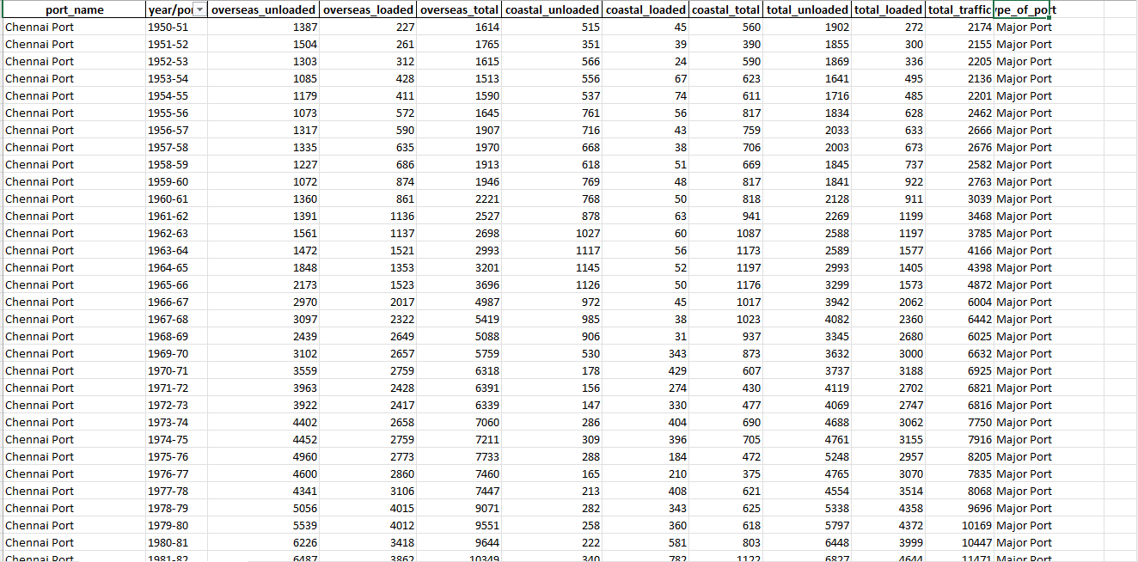

2. Source of Dataset
The dataset utilized for this project is the Indian Ports and Fleet Performance Dataset, obtained from the Ministry of Ports, Shipping and Waterways (MoPSW) and the Indian Ports Association (IPA) official publications. The data, which is updated annually, includes a wide range of port-level performance metrics, such as cargo handled, berth output, fleet distribution, gross tonnage (GRT), and turnaround time (TRT). This dataset offers valuable insights into the performance of Indian ports and fleet dynamics, making it ideal for analyzing trends in cargo movement, fleet growth, and regional differences in port performance.
The specific dataset used in this project was downloaded on 11-03-2025 and contains data from various major and non-major ports across India. This data enables an in-depth examination of operational efficiency, cargo distribution, and fleet modernization efforts. It is part of a broader initiative to improve the efficiency of India's maritime infrastructure, aiding in policy formulation, resource allocation, and infrastructure development. The dataset also includes historical performance data, providing a comprehensive view of the sector's growth and areas requiring attention.
To ensure accurate interpretation, the dataset was supplemented by a data dictionary, which defines the various metrics and their measurement criteria. The dataset is publicly available under open data policies, allowing for transparency and accessibility, supporting projects aimed at improving India's port operations and fleet performance.
To ensure accurate interpretation, the data dictionary was also downloaded from the same source. The dataset is publicly available under open data policies, making it an ideal resource for educational projects like this one conducted under the guidance of [Dr. Baljinder Kaur] at Lovely Professional University.

3. Dataset Preprocessing
To ensure accurate and meaningful analysis, extensive preprocessing was performed on the raw dataset before dashboard creation. The preprocessing phase was executed entirely in Microsoft Excel and included the following key steps:
a. Data Cleaning
- Removal of Null/Empty Rows & Columns: Any blank or redundant data entries were removed to maintain dataset integrity.
- Standardization of Date Formats: All date fields were uniformly formatted (e.g., YYYY or DD-MM-YYYY) to ensure consistency in time-series visualizations.
- Correction of Typographical Errors: Port names, regions, and coast labels were corrected for consistency using Excel's FIND, REPLACE, and TRIM() functions.
- Handling Missing Values: Missing numerical data points (such as cargo volume or GRT) were either filled using averages or left as blanks for transparency, depending on the objective.
b. Data Formatting
- Number Formatting: Large numerical values were abbreviated (e.g., 1,000,000 displayed as 1,000K) using custom number formats to enhance readability.
- Currency & Percentage Fields: Metrics like revenue or growth were formatted using appropriate currency and percentage styles.
c. Classification and Grouping
- Port Categorization: Ports were classified as Major or Non-Major based on official MoPSW guidelines using Excel’s IF() and VLOOKUP() functions.
- Regional Grouping: Data was grouped by East and West Coast using a mapping table for regional segmentation.
d. Creating Derived Metrics
- Calculated Columns: New columns such as Average Output per Berth Day, Turnaround Time Efficiency, and Fleet Age Bucket were created using formulas.
- Logical Conditions: Used IF(), AND(), OR() to derive custom insights and categorize data.
e. Pivot Table Preparation
- The cleaned and formatted dataset was structured to support PivotTable creation, enabling fast multi-dimensional summaries and filtering.
f. Data Validation & Integrity
- Data Validation Rules: Dropdowns and restricted input ranges were applied using Excel's Data Validation feature.
- Named Ranges & Dynamic Tables: Used OFFSET() and INDEX() for dynamic data ranges to ensure visualizations auto-update with new data entries.

4. Analysis on Dataset (for Each Objective)
Objective 1: Cargo Handled Trend Analysis
i. Introduction:
To analyze the year-on-year growth in cargo handled across Indian ports.
ii. General Description:
The data includes annual cargo volumes from 2010 to 2024, covering both Major and Non-Major ports.
iii. Specific Requirements:
- PivotTable: Rows = Year, Values = Total Cargo Handled
- Functions: SUM()
- Chart Type: Line Chart
iv. Analysis Results:
A clear upward trend in cargo handled, with substantial growth after 2020, indicating recovery and expansion post-COVID.
v. Visualization:
Line Chart titled “Cargo Handled Trend (2010–2024)”

Objective 2: Major vs Non-Major Ports Comparison
i. Introduction:
To understand cargo distribution between Major and Non-Major ports.
ii. General Description:
Categorized port data showing cumulative cargo volume.
iii. Specific Requirements:
- PivotTable: Rows = Port Type, Values = Cargo Handled
- Function: SUM()
- Chart Type: Pie Chart
iv. Analysis Results:
Major Ports handle over 70% of the cargo, emphasizing their central role in national trade.
v. Visualization:
Pie Chart titled “Cargo Distribution: Major vs Non-Major Ports”

Objective 3: Top Performing Ports
i. Introduction:
To identify top 10 ports based on cargo volume.
ii. General Description:
Port-wise cargo statistics were ranked.
iii. Specific Requirements:
- PivotTable: Sorted in descending order of cargo
- Function: LARGE(), SORT()
- Chart Type: Horizontal Bar Chart
iv. Analysis Results:
JNPT and Paradip consistently emerge as top performers.
v. Visualization:
Bar Chart titled “Top 10 Performing Ports”

Objective 4: Age-wise Fleet Distribution Over Time
i. Introduction:
To track changes in fleet composition by vessel age.
ii. General Description:
Fleet data categorized into age brackets over multiple years.
iii. Specific Requirements:
- PivotTable: Rows = Year, Columns = Age Groups
- Chart Type: Clustered Column
iv. Analysis Results:
A gradual decline in older vessels; increase in mid-age and newer ships.
v. Visualization:
Clustered Column Chart titled “Fleet Age Distribution Over Time”

Objective 5: Fleet Growth Trend
i. Introduction:
To analyze long-term growth in the number of vessels.
ii. General Description:
Fleet size recorded from 1947 to 2024.
iii. Specific Requirements:
- PivotTable: Rows = Year, Values = Vessel Count
- Chart Type: Line Chart
iv. Analysis Results:
Significant fleet expansion after liberalization, with steady growth continuing post-2000.
v. Visualization:
Line Chart titled “Growth of Indian Fleet (1947–2024)”

Objective 6: Coastal vs Overseas GRT Trend
i. Introduction:
To compare growth of coastal vs. overseas gross tonnage.
ii. General Description:
Yearly GRT data divided into coastal and overseas segments.
iii. Specific Requirements:
- PivotTable: Rows = Year, Columns = Type (Coastal/Overseas), Values = GRT
- Chart Type: Clustered Column
iv. Analysis Results:
Overseas GRT consistently surpasses coastal, showing India's focus on international shipping.
v. Visualization:
Clustered Column Chart titled “Coastal vs Overseas GRT Trend”

Objective 7: Total GRT in Indian Fleet
i. Introduction:
To observe the cumulative GRT of the Indian shipping fleet over time.
ii. General Description:
Total GRT numbers plotted by year.
iii. Specific Requirements:
- PivotTable: Rows = Year, Values = Total GRT
- Chart Type: Vertical Bar Chart
iv. Analysis Results:
Positive trend reflecting increase in ship capacity and fleet modernization.
v. Visualization:
Bar Chart titled “Total GRT in Indian Fleet”

Objective 8: All Ports Performance Comparison
i. Introduction:
To compare cargo handling capabilities of all ports.
ii. General Description:
Port-wise cargo output without filtering top performers.
iii. Specific Requirements:
- PivotTable: Rows = Port Names, Values = Cargo
- Chart Type: Column Chart
iv. Analysis Results:
Significant variation in output top ports handle exponentially more than smaller ones.
v. Visualization:
Column Chart titled “All Ports Cargo Handling Comparison”

Objective 9: East vs West Coast – Avg Output per Ship Berth
i. Introduction:
To compare berth productivity between the east and west coasts.
ii. General Description:
Berth output per coast calculated for various years.
iii. Specific Requirements:
- Calculations: Output per berth/day
- Chart Type: Grouped Bar Chart
iv. Analysis Results:
Western ports outperform eastern ports in productivity.
v. Visualization:
Grouped Bar Chart titled “Avg Output per Berth: East vs West Coast”

Objective 10: Turnaround Time (TRT) Trend – East vs West Coast
i. Introduction:
To track ship turnaround efficiency over time by region.
ii. General Description:
TRT data recorded by year and coast.
iii. Specific Requirements:
- PivotTable: Rows = Year, Columns = Coast, Values = Avg TRT
- Chart Type: Line Chart
iv. Analysis Results:
Both regions show reduced TRT, with east coast catching up to west.
v. Visualization:
Line Chart titled “Turnaround Time Trend – East vs West”

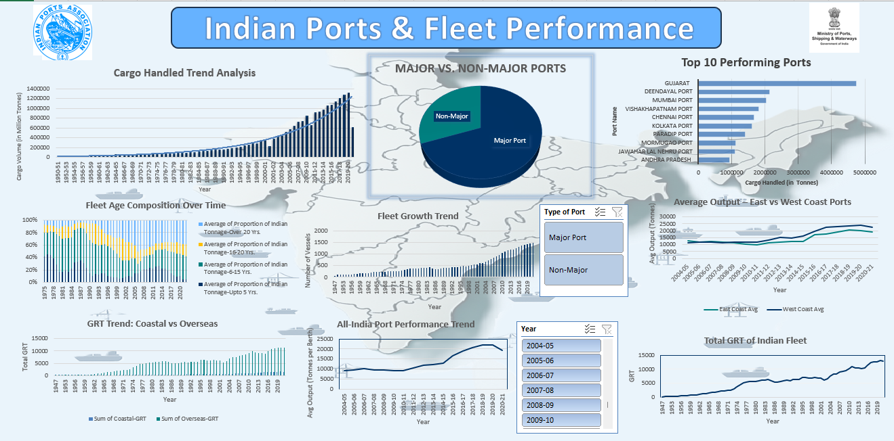
5. Conclusion
The Indian Ports & Fleet Performance Dashboard successfully transforms complex maritime data into an accessible and insightful visual format. By applying structured data preprocessing, exploratory analysis, and dynamic Excel features such as PivotTables, slicers, and conditional formatting, the project achieves its objective of simplifying port performance evaluation across key indicators.
The dashboard reveals critical insights such as consistent growth in cargo handling, dominance of major ports, improvements in fleet modernization, and decreasing turnaround time highlighting operational strengths and areas for further optimization. It also facilitates comparison between eastern and western coast ports, providing stakeholders with region-specific performance trends.
This project not only demonstrates the power of Excel as a visualization and analytics tool but also serves as a practical application of data science principles in a real-world maritime context. It equips decision-makers, policymakers, and students with a user-friendly, interactive platform to analyze and interpret key metrics from the Indian shipping and port industry.
Overall, this initiative contributes meaningfully to the digital transformation of maritime analytics and sets a strong foundation for future advancements involving automation, geospatial mapping, and predictive modeling.

6. Future Scope
While the current dashboard provides valuable insights into Indian port operations and shipping trends, there is significant potential to enhance the project further. The following future enhancements can be explored:

1. Integration with Real-Time Data Sources
- Connect the dashboard to live APIs or government databases (e.g., MoPSW, IPA) to reflect real-time port performance metrics, vessel movements, and cargo trends.
2. Migration to Advanced BI Tools
- Upgrade the project to tools like Power BI or Tableau to leverage advanced data modeling, automated updates, and interactive storytelling capabilities.
3. Automation with Python
- Use Python scripts for data cleaning, transformation, and monthly dataset updates to reduce manual effort and improve consistency.
4. Geospatial Visualizations
- Incorporate maps and spatial analytics (e.g., port locations, regional traffic density) to provide geographical context and enhance decision-making.
5. KPI Dashboards for Stakeholders
- Create role-specific dashboards for port authorities, shipping companies, and policymakers with customized KPIs and alerts.
6. Comparative Global Analysis
- Expand the scope by comparing Indian port performance with leading global ports (e.g., Singapore, Rotterdam, Shanghai) to identify best practices and competitiveness.
7. Predictive Analytics
- Use machine learning techniques to forecast cargo volumes, turnaround times, and fleet expansion, enabling proactive planning and strategic investment.
These advancements can transform the project into a scalable, intelligent decision-support tool for the Indian maritime sector.

7. References
- Ministry of Ports, Shipping and Waterways: https://shipmin.gov.in/
- Indian Ports Association: https://www.ipa.nic.in/
- Sagarmala Programme: https://sagarmala.gov.in/
- Data compiled and processed in Microsoft Excel, 2025
- Project guided by Dr. Baljinder Kaur, Lovely Professional University

